**NORTH-WEST EUROPE – PARTNER SEARCH –**

**UPDATE 3 APRIL 2018 > RVO.NL**

1. **Project title: Rethink Electricity Distribution WithOut Load-Following (RED WOLF)**

**Objective**

RED WOLF will cut CO2 that homes with PV panels emit in NWE. A standardized

electric plus thermal storage combined solution will be tested in an operational

environment and will be brought closer to market-readiness by the end of the project.

This will reduce electricity peak demand in NWE which, in turn, will enable the

integration of a higher share of intermittent renewable energy sources in the Power

grid.

**Project Outline**

**(What the project will do, where, why, demonstrators/pilots)**

RED WOLF aims specifically at reducing CO2 from homes with photovoltaics (PV).

Batteries plus power-to-thermal storage (the latter used for heating the home) will

keep in the house the electricity generated by domestic PV and will also download

from the Power Grid low CO2 energy for later use. This approach will solve the

current mismatch between generation and demand, one of the stronger forces

preventing renewable energy growth. Presently, at times of low demand in

sunny/windy days, output from large-scale solar- and wind-farms must be reduced,

wasting the cleanest possible electricity. A few hours later on the same day (at times

of high-demand, e.g. dinner time) intensive CO2 fossil-fuel plants are turned on to

match demand. PV power is currently uploaded to the Power Grid regardless of the

Grid’s needs: this increasingly exacerbates the generation-demand mismatch as the

number of PV installations grows year after year in NWE. Current RED WOLF

partnership’s test-sites are located in UK, EIRE and Belgium and consist in both

microgrids and individual homes. Test sites from other NWE countries are welcomed.

**Intended Results**

CO2 from homes will be reduced and the capacity of the Power Grid to integrate

renewables will be proportionally increased.

**Project Partners Required**

**(Partners required: sector, expertise, anticipated contribution to the project)**

We are looking, in continental NWE only, for additional test sites, Power Grid operators

and public authorities interested in the proposed solution for their territories. We would

also like to hear from university researchers (electrical engineering/ environment

/physics) and enterprises interested in electricity distribution/renewables integration.

**Contact Details**

Dr Giuseppe Colantuono, Leeds Beckett University, Leeds, UK

g.colantuono@leedsbeckett.ac.uk

0044 (0)74155 97850

+++++++++++++++++++++++++++++++++++++++++++++++++++++

1. **Project title: Improving resource efficiency of agribusiness supply chains  
   by minimizing waste using Big Data and Internet of Things sensors (REAMIT)**

|  |
| --- |
| Objective |
| In this proposal, we aim to identify, develop and test solutions based on the Big Data and IoT sensors in reducing waste and hence in improving resource efficiency of NWE agribusiness supply chains.  The aim of the project will be achieved by attaining the following objectives:   1. To explore potential of Big Data and IoT sensors in reducing waste in the agribusiness supply chain until it reaches final consumer. 2. To identify suitable technology options for use in reducing waste in the agribusiness supply chain until it reaches final consumer. 3. To identify technology adoption potential in SMEs/NGOs/charities in NWE in utilising IoT sensors in their supply chain until it reaches final consumer. 4. To test the potential of specific types of IoT sensors in reducing waste in the agribusiness supply chain. 5. To conduct technology assessment and to estimate the improvement in resource efficiencies of agribusiness supply chain by the deployment of IoT sensors in their supply chain. 6. To develop and pilot a food waste monitoring app for all actors involved in food supply chains, e.g. food producers, supply chain operators, retailers, and consumers (particularly in the hospitality sector). 7. To develop roadmaps to policy makers and to SMEs/NGOs/Charities on the best practices in using ioT sensors for reducing waste in the agribusiness supply chain   The project target group are partners in agri-food (dairy products, fish and meat) supply chain including farmers, processors and wholesalers, retailers, and consumers.  The REAMIT project is distinct from the Food Heroes project already funded by Interreg NWE in that the focus of REAMIT project is entirely on the use of IoT abd Big Data technologies. In this sense, the REAMIT project will complement Food Heroes project. |

|  |
| --- |
| Project Outline  (What the project will do, where, why, demonstrators/pilots) |
| Data shows that each year waste in EU agri food sector is estimated to amount to 88 million tonnes, which is equivalent to EUR 5 billion, which corresponds to approximately EUR 2 billion in NWE region countries. Due to the amount of resources (water, nutrients, fertilisers, etc.), food waste saved is much more than the value of waste and can have significant social and environmental benefits. This project proposes to use latest Big Data and Internet of Things sensor technologies to help NWE economies optimize the use of material and natural resources when the food moves along the supply chain until it reaches the final consumer. We estimate that about 10-15% of waste at the least can be eliminated in this way and thus reduce food waste by about 3-5 million tonnes or about EUR 200-300 million per year in the NWE region. This will not only minimise waste but also help improving resource efficiency of the entire supply chain.  This project matches with Priority 3 of NWE Programme: Resources & materials efficiency and Specific Objective 5 - Optimize the use of materials and natural resources in NWE region.  The project will deliver the following activities for each of the objectives:   * Identify SMEs/NGOs/charities engaged in NWE in dairy/fish/meat supply chains (which will include not only farmers but also processing manufacturing SMEs and NGOs/Charities engaged in redistributing – at low cost or no cost - excess food to final consumers) and to conduct a large scale questionnaire survey on the adoption potential of IoT sensors in the supply chain. * Literature review on the Big Data and IoT technologies in reducing waste in diary/fish/meat agribusiness supply chain. * Liaise with manufacturers of IoT sensors and identify suitable technologies for use. * Field experiments by trialling specific sensors and testing the efficiency in minimising waste along the supply chain.   + A variety of technological opportunities will be attempted. A specific example is to track both the location and the quality of food in trucks when the produce is in motion. If, for some reason, the produce is expected to deteriorate faster than expected (for example due to failure in temperature control), then the produce can be rerouted to nearby markets for sale before the produce becomes inedible. A big data based platform will be used to link to potential buyers in nearby locations. This example will use IoT sensors for tracking location, temperature and food quality, a blockchain technology to keep track of all these activities, a big data platform to link buyers and sellers, and also link to charities/NGOs. The blockchain technology helps to trace the origins of food increasing transparency along the supply chain. More details are available in the figure below.   + These field experiments will be attempted using SMEs, technology specialists, sellers/buyers/charities in the NWE region. This region has advanced agri-food supply chain where new technology can be deployed. * Design and develop food waste monitoring app(s) for all actors involved in food supply chains from food producers to end consumers. * Test food waste monitoring apps for all actors involved in food supply chains * Implement food waste monitoring technologies * Analysis and development of roadmaps. |

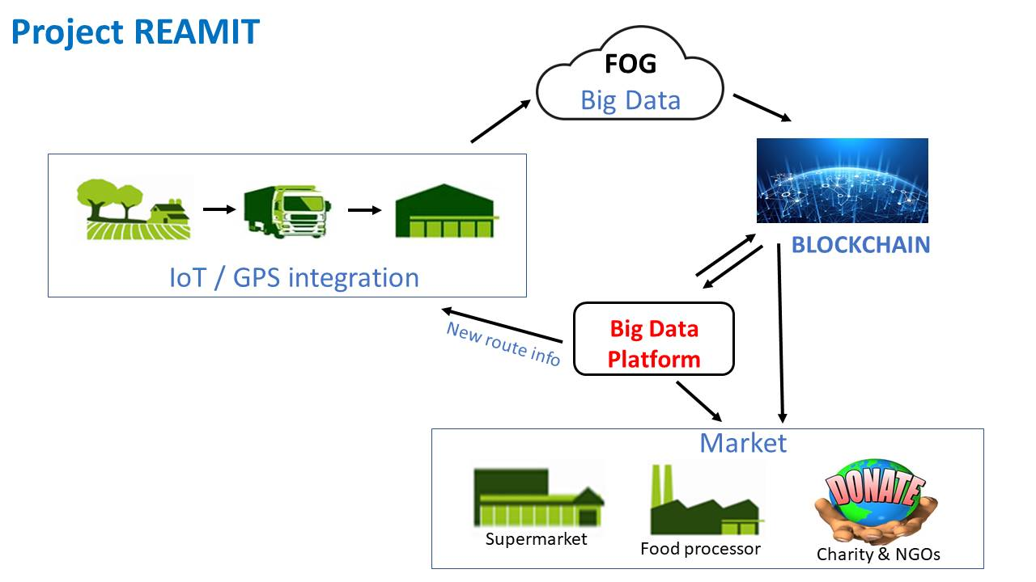

|  |
| --- |
| Intended Results |
| *The project will create the following tangible outcomes on the ground:*   * The project will identify 4 most suitable IoT sensor technologies for using in diary/fish/meat supply chains to minimize the amount of diary/fish/meat wasted. They include technologies that monitor the temperature of the trucks when diary/fish/meat is transported, temperature of the warehouse when diary/fish/meat is stored, sensors that track the colour of diary/fish/meat, and sensors that senses the gases emitted so that good diary/fish/meat can be distinguished from bad. * 4 solutions / technologies tested and implemented * EUR 1 m leveraged by the project * 10-15% in agri food waste saving annually in NWE economies * 20 enterprises receiving support * 5 enterprises collaborating with research institutions |

|  |
| --- |
| Project Partners Required  (Partners required: sector, expertise, anticipated contribution to the project) |
| * Agribusiness SMEs and related public bodies * IoT sensor technology firms * Big Data agritech firms * Research Institutions |
| Contact Details |
| Professor Ram Ramanathan and Professor Yanqing Duan  Ram.Ramanathan@beds.ac.uk  Yanqing.Duan@beds.ac.uk  Business and Management Research Institute  University of Bedfordshire, UK |

++++++++++++++++++++++++++++++++++++++++++++++++++++++++++++

1. **Alleviating Fuel Poverty with Microhydro in Wales**

We have been contacted by a UK organisation based in Wales that would like to develop a project in the field of micro-hydro generation, specifically weirs in rivers.

The technology is proven but it is not used as much as it could be. The idea is to support the uptake of the technology, especially in areas affected by fuel poverty or with poor connection to the grid. Please find attached two documents that describe the technology and the issue more in details.

The project could look at reducing the barriers to the uptake, increasing the capacity of local groups to implement and manage hydro schemes, piloting implementation of small hydro-powers installations, etc.

The project will need organisations such as public authorities, interest groups in local energy, planning authorities, etc.

The organisation is a private sector company so we are also looking for partners that could be interested to be LP.

The project could fit under SO3, but depending on the responses, it could be adapted to SO2. Ideally it would submit under call 7.

We would be grateful if you could disseminate this to your relevant contact and feel free refer any interest back to our contact: Melissa Johansson mjohansson@geode-energy.com

**Alleviating Fuel Poverty with Microhydro in Wales**

Dr. M. Johansson, Geode-Energy Ltd

Fuel poverty is when a household spends 10% or more on their income on energy cosst. Currently in Wales 23% or 291,000 households are classified as living in fuel poverty. Many of these regions are mountainous areas with a rainfall between 200 - >500mm per year, well above average. Ideal conditions for implementing microhydro schemes.

Run-of–the-River Hydro electricity generation, utilizes the natural flow of the river, extracting water from a high point, where it flows to a micro turbine generator, where the kinetic energy is captured. In general, the Run-of-the-River systems have an installed capacity of between <100kW to 5MW, with an efficiency of over 80%, and it remains one of the cheapest forms of renewable energy. considering the annual rainfall is abundant in the UK.

One current example of a renewable energy scheme is in Bargoed Hydro Scheme which uses water from the Taff River to generate electricity. The gross head of the system has been calculated as 23m with a mean flow of 0.6m3/s. The turbines chosen for such a project were cross flow turbines to generate a maximum of 100kW. Currently the scheme has a reported average capacity factor of 172%with outputs between 70-128MWh per month, generating an income between £2604 - £6928, with construction cost only £500,000.

Although the economics are less than attractive, especially with fluctuating Feed-in-Tariffs, the value of producing electricity in the winter months when it is needed most, with little to no carbon footprint cannot be quantified. Potentially selling the carbon savings to local polluting industries could be developed to enhance the finacial viability of these smaller projects. Combining micro hydro with shallow geothermal heating systems could also potentially offset the costs.

++++++++++++++++++++++++++++++++++++++++++++++++++++++++++++++++++++++++

1. **CL-AIR: Solutions for Clean Ambient Air in Cities**

**The lead partner is currently looking for:**

**1)      Cities interested in participating as pilot**

**2)      Companies specialized in air quality solutions for outdoor**

**Please encourage interested organizations to contact directly the lead partner**

|  |  |
| --- | --- |
| **Project idea title** | **CL-AIR: Solutions for Clean Ambient Air in Cities** |
| **Lead partner**  **Contact person** | University of Antwerp, Belgium  Dr. Jan Cools; Institute of Environment & Sustainable Development  **Jan.cools@uantwerpen.be** |
| **Programme Specific Objectives** | SO1: To enhance innovation performance of enterprises throughout NWE regions |
| **What is the need?** | * Inadequate capacity of cities to address air pollution, reflected in observed exceedances * Air quality solutions on the market insufficiently known by potential clients: cities, schools, companies & citizens * Existing solutions work on local scale, but not yet tested to solve complex air quality problems in cities, like tunnels exits, street canyons, playgrounds, metro stops, … * Objective monitoring & evaluation to assess performance in actual air quality improvements * Need for an online platform that brings air solution providers together with clients in need of a solution, while also serving to exchange knowledge on how to choose solutions |
| **What is the overall objective of your project (which problem do you want to answer to)?**  **Type of actions** | Overall objective:  Build capacity of cities to plan and implement innovative solutions to achieve urban air quality below standards. A range of technological solutions (preventative and end-of-pipe) are considered.  Specific objectives / actions:   1. Build capacity of regions and territories  * Build capacity on the concept of integrated urban air quality management and how to implement it * Develop a catalogue of solutions (technological, green, social, economic) for clean air at city scale reflecting key planning indicators, such as cost-effectiveness, co-benefits, boundary conditions for implementation and resources needed  1. Improving competitiveness of enterprises  * Test innovative air quality solutions in complex real-life conditions with bad air: street canyons, tunnel exits, schools, metro stops * Support the delivery of solutions to cities through the development of an online platform that brings air solution providers together with clients in need of a solution, while also serving to exchange knowledge on how to choose solutions  1. Delivering societal benefits through innovation  * Demonstrate the pathway from problem definition, to planning and implementation of urban air quality management * Set-up (or strengthen) multi-actor platforms, for each demo city, for co-ordination, co-planning and co-implementation on urban air quality management * (developing new public service delivery mechanisms??) |
| **What do you envisage to deliver? (please describe tangible and concrete outputs)**  **Output indicators** | Programme specific output indicators proposed   * Number of new or enhanced transnational clusters or innovation networks : 1 transnational, also in each city?? * Add Number of demo cities?? * Number of technologies, products, services and processes developed and tested in real life conditions: 10 * Number of jobs created in all economic sectors: ? * Number of jobs maintained in all economic sectors: ? * Amount of funding leveraged by the project (in €) - as co-fin or additionally collected throughout the project?? * Number of end-users benefitting from social innovation: inhabitants of the demo cities * Number of pilot actions implemented, focusing on   social innovation: ? demo cities  **Common output indicators proposed:**   * CO 1- Number of enterprises receiving support - including social entreprises: about 5 as partners, more indirectly through the innovation cluster * CO26 - No. of enterprises co-operating with research institutions - about 5 as partners * CO28 - Number of enterprises supported to introduce new to the market products: ?? * CO29 - Number of entreprises supported to introduce new to the firm products: ?? |
| **What is the expected concrete change you want to make on the ground? (expected results)** | Increased SME innovation levels ??   * Improved capacity of cities to achieve urban air quality below standards * Better cooperation and coordination between city authorities, citizens, companies and universities on urban air solutions * Better understanding on the feasibility and performance of solutions for ambient air * Improved air quality at demo locations within cities |
| **Why is cross-border collaboration needed for your project? (please describe the cross-border added-value of your project)** | * Exceedances of air quality standards in many cities urge for effective air quality planning and consequent implementation. * Inadequate capacity of cities to address a complex problem like air pollution. Existing urban air quality plans insufficiently specific, e.g. on priority and target setting, cost-effectiveness of solutions and means for implementation |
| **Partnership** | (participation of most partners still be confirmed). Only partners 1-4 have been invited.  **BE**   1. University of Antwerp, BE (integrated approach) 2. Flemish Environment Agency, BE (monitoring and planning at regional scale) 3. City of Antwerp, BE (DEMO)   **UK**   1. Southend-on-Sea council, UK (DEMO) 2. Imperial College London, UK (local scale modelling of effects, using CFD) 3. Airlabs.com, UK, company creating clean air zones   **NL**   1. DCMR, NL, joint environmental protection agency South Holland and 16 municipalities (DEMO) 2. Studio Roosegaarde, NL (company, smog free towers, smog free bikes)   **DE**   1. Green City Solutions, DE (bio-tech, city-tree, super moss filters for air purification) 2. City of Stuttgart (DEMO)   **FR**   1. University of Strasbourg, FR (Alain Clappier) – Expert in SHERPA, model for air quality planning 2. Air Lab Solutions, FR – innovation accelerator at Airparif, île de France, FR (<http://www.airlab.solutions/en>) |

DEMONSTRATORS

SUSTAIN OF ALTERNATIVE ENERGY

DUPLICATION